

CENTENNIAL COLLEGE PROGRESS CAMPUS

COURSE COMP125

Assignment 2

DOM

Modify the Chapter 5 example (photo viewer) to include the following features:

1. When the user clicks on a picture and it opens a window containing a zoomed version of the image, give her a hyperlink (button) to add the pic to a favourites area at the bottom of the first page (add img nodes to the DOM).
2. A maximum of 5 pics can be added to the favourites. After that, a message is displayed to remove at least one favourite first.
3. If the user clicks on a favourite, a Remove link (button) shows up next to that picture. If the user clicks it, the pic is removed from the favourites.
4. (**10% of the grade**) Use good web design practices to enhance visually your HTML page. Add a title, picture, copyright line, etc.

Basic screenshots for the functionality of this assignment are shown below:

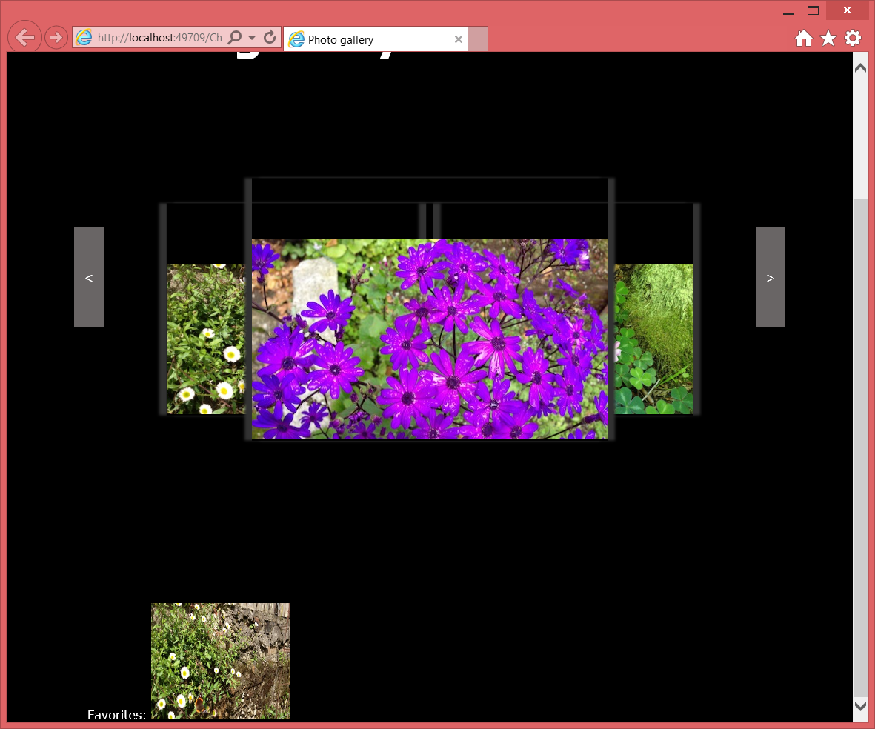

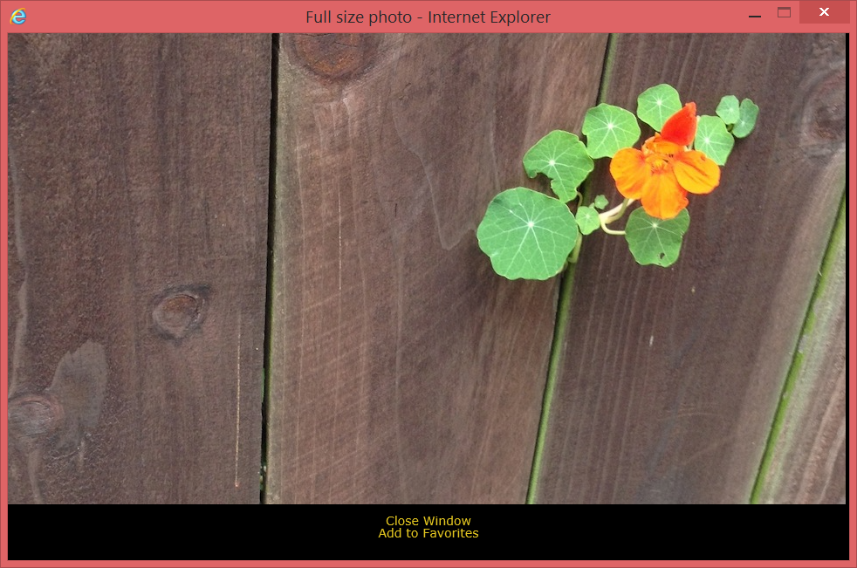

Submit your assignment to the Midterm Hands-On drop box. ALSO, PUBLISH IT to the student web and include the link in the Assignment 2 drop box.